**Web Application Design – goParks Practical Design**



Nyima T. Sherpa 14079534

**goParks State Chart:**

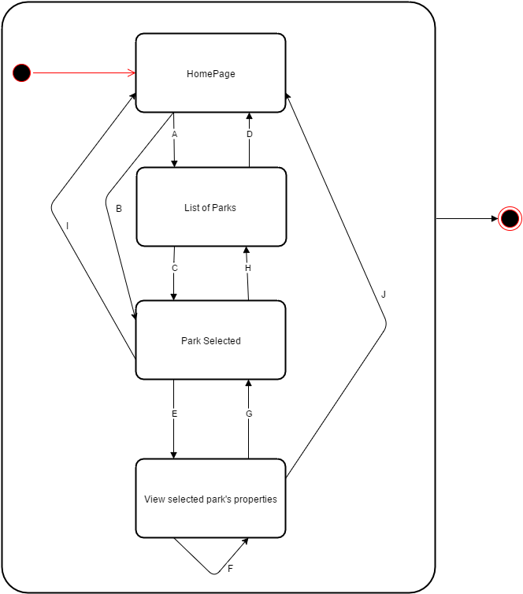

**Start state:** Home Page will show a list of parks from user’s location that is generated automatically via “geo-location”.

**A:** If user requires a different park that is not on the list, then user can search specific parks via “search button” on the home page.

**B:** If the park that user wants to search for is on the “List of parks generated via geolocation” then it can be selected.

**C:** If the desired park is on the “List of Searched results” then the park can be selected.

**D:** List of Parks generated by the “search” does not contain the park that user wants to select, user can go and search again.

**E:** User can view the properties of the “selected” park after the filtrations.

**F:** User can choose to save the “selected Park” so that user can view the park’s properties (maps, photos etc.) without connecting to the internet.

**G: H: I: J:** User can go back to the previous page via “Breadcrumb trail” navigation.

**End state:** At any state/transition, user can exit the goParks site by closing it down.

**Page Design Wireframe:**

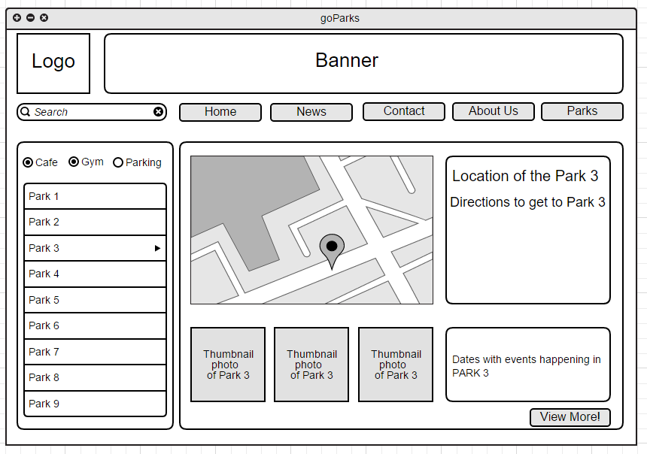Presentation and Filtering of available locations:

Figure 1: On the left side of the content page- it'll display the map/properties of the park once you click on the Parks from the "List of Parks" on the left generated by the "search" button or via geolocation. Also important to note is that I’ve not included the “breadcrumbs” style navigation there due to my lack of experience/knowledge on how to implement one with only css/html (however it is possible to implement it via JavaScript)

*Note – Clicking the “View more!” button will take you to the page where there is more details of the park and where user can interact with the park itself in more detail.

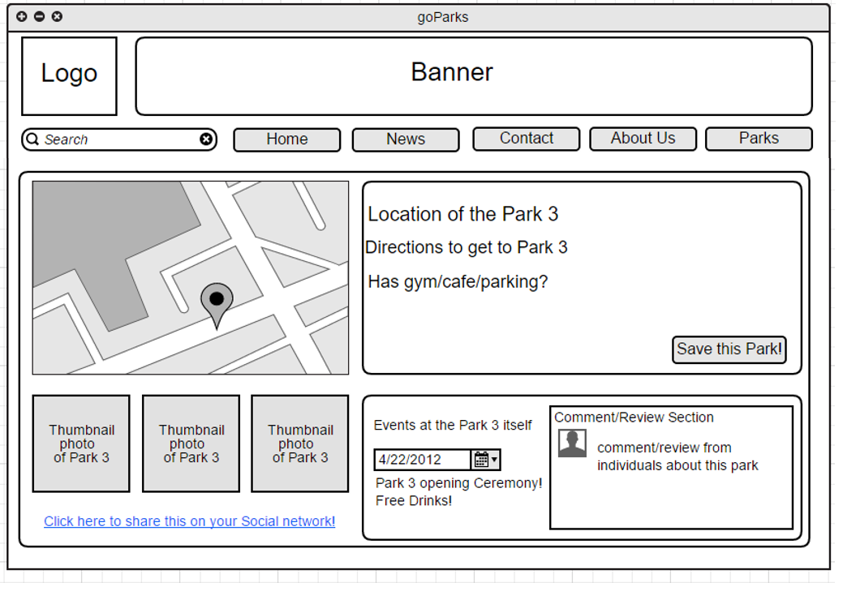Display of and interaction with, the detailed Park Information:

Figure 2: Clicking on the “Save this Park!” will allow the user to view this park later on without the need to connect to internet again.

**Commentary: Aesthetic and minimalist design – I believe that having lots of information that doesn’t serve any functional requirements to the betterment of the page should not be there as average people spends roughly up to 10-20 seconds only on a page according to Jakob Nielsen** (Nielsen, 2011)**. Therefore it is essential that almost everything on the page will be there for a purpose. Minimalistic designs with clear Images will help user from “getting bored”. Picture speaks louder than words.**

**Consistency and standards – Having an aesthetic and minimalistic design will aid in having a consistent as user won’t have to deal with a huge number of buttons/links. By only changing the lower part of the webpage and keeping the global navigation up top will serve to bolster the “consistency” of the page and keep the standard of page navigation to optimum. Having all the buttons shaped similar will aid the users in identifying the buttons on the page.**

**Match between your site and the real world** – **Since the user for the goParks can be from any background, making a consistency/standard and aesthetic/minimalistic design was the key because a site with consistent navigation and minimalistic design will be able to access by everyone, even the kids.**

**Structural Mark-up using HTML5 version:**

Browser cross-compatibility – I wanted my application to be accessible by as many users as possible and my elements in code to be supported by different browsers and html5 version offers this more than any other versions.

Neater code: I believe that your code should do a lot more than what is designed to do and html5 does that via “search engine readability”. Hence higher search rankings.

Mobile optimization- Everyone owns a mobile devices and html5 is designed with just that in mind.  Implementation of having a functional website without the need for long horizontal scrolling when viewed using your mobile devices. Improves the overall efficiency of your browsing.